Experiment: 4
Create and configure storage services and upload files and objects using Amazon EBS, Amazon EFS and Amazon S3

Part-1: Attach and Mount Extra EBS(Amazon Elastic Block Store) Volume to Linux EC2 in AWS
- Login into AWS Account

2.Start Lab and Launch AWS Console Home
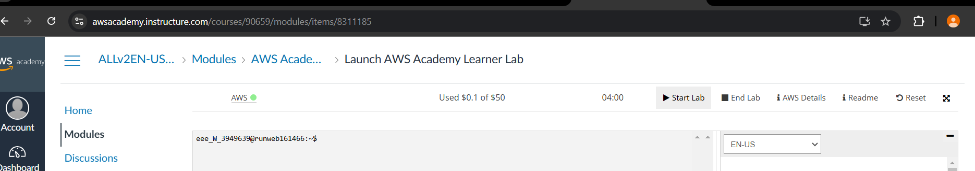
3.Search for EC2 in services and click on it
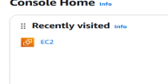

4.Click on Launch instance
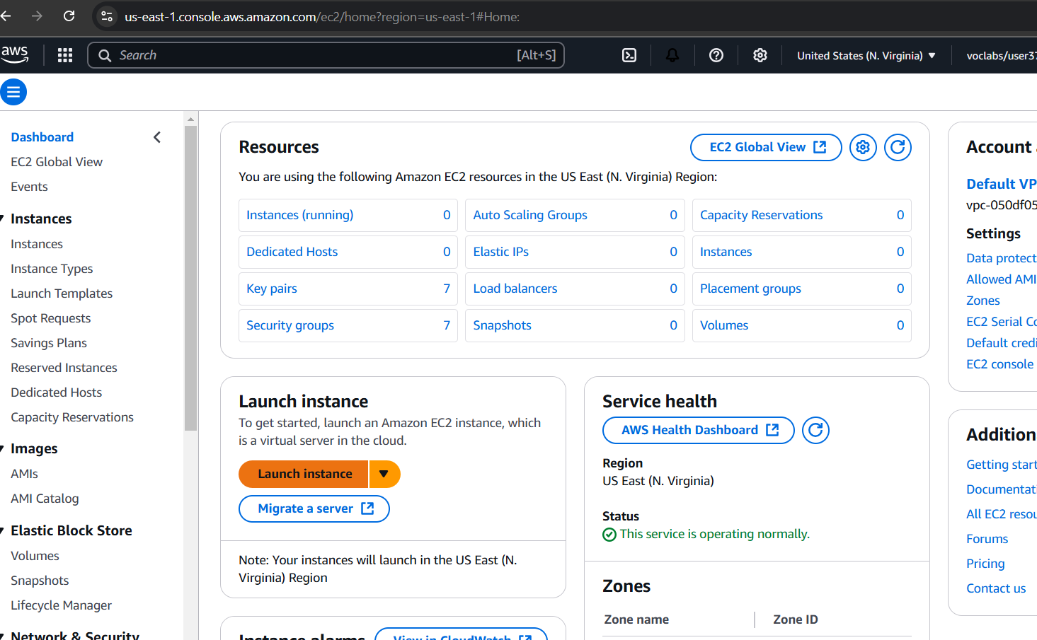
5.Create instance with Name as 22bd1a057a

6. Generate key pair and use it
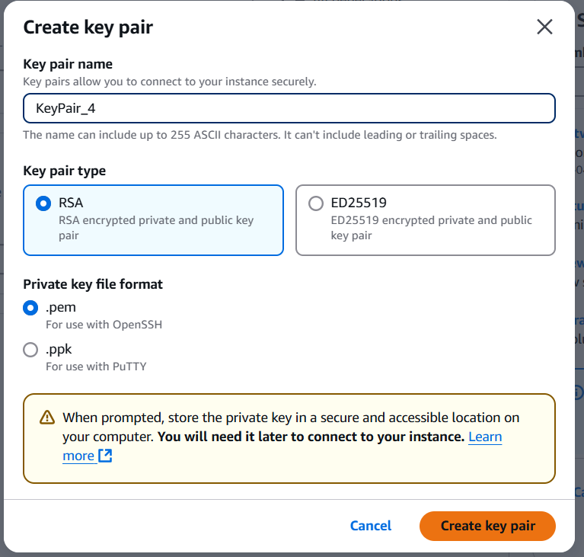
7.Finally launch the instance
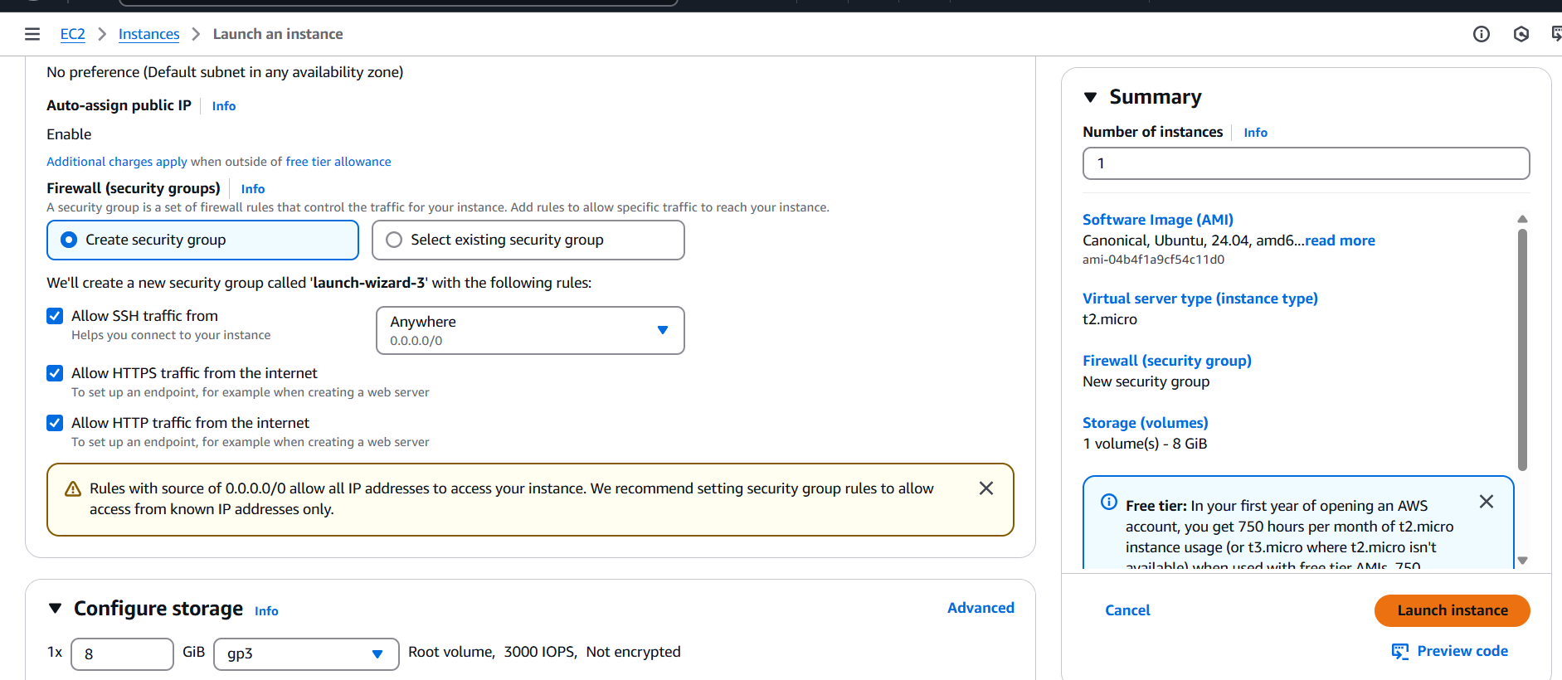
8.Instance launched successfully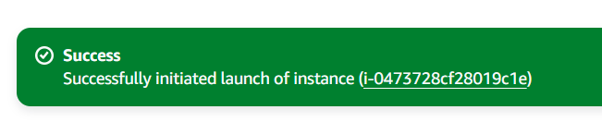
9.Click & select your Instance you will find Storage. While clicking Storage you can see the below details with Volume size 8(GiB), Volume ID etc.
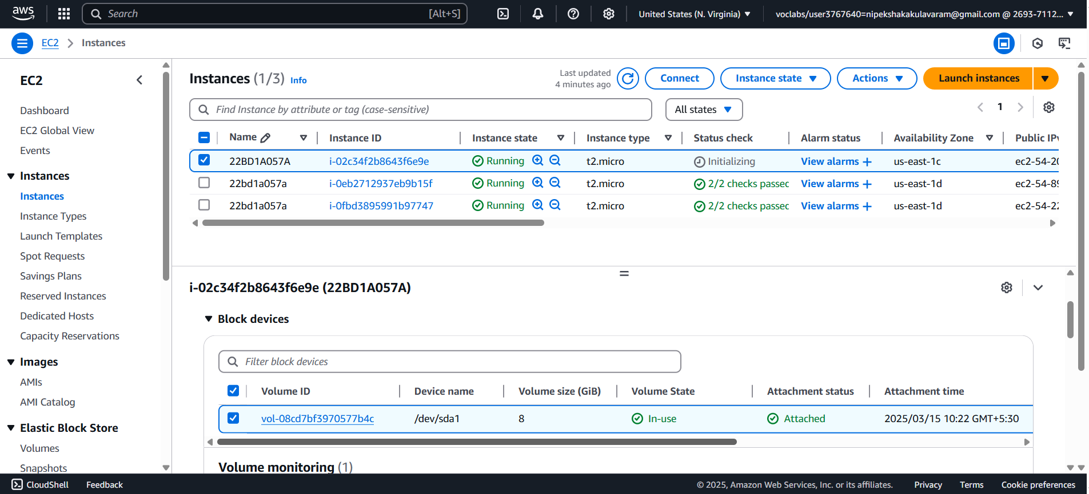
10.To create New Volume of 10GB on left hand size pallet you find Elastic Block Store under that Volume

11.Click on Volumes as a new tab, you will navigate to below picture
Note: Check the Instance Volume ID & EBS Volume ID should be same

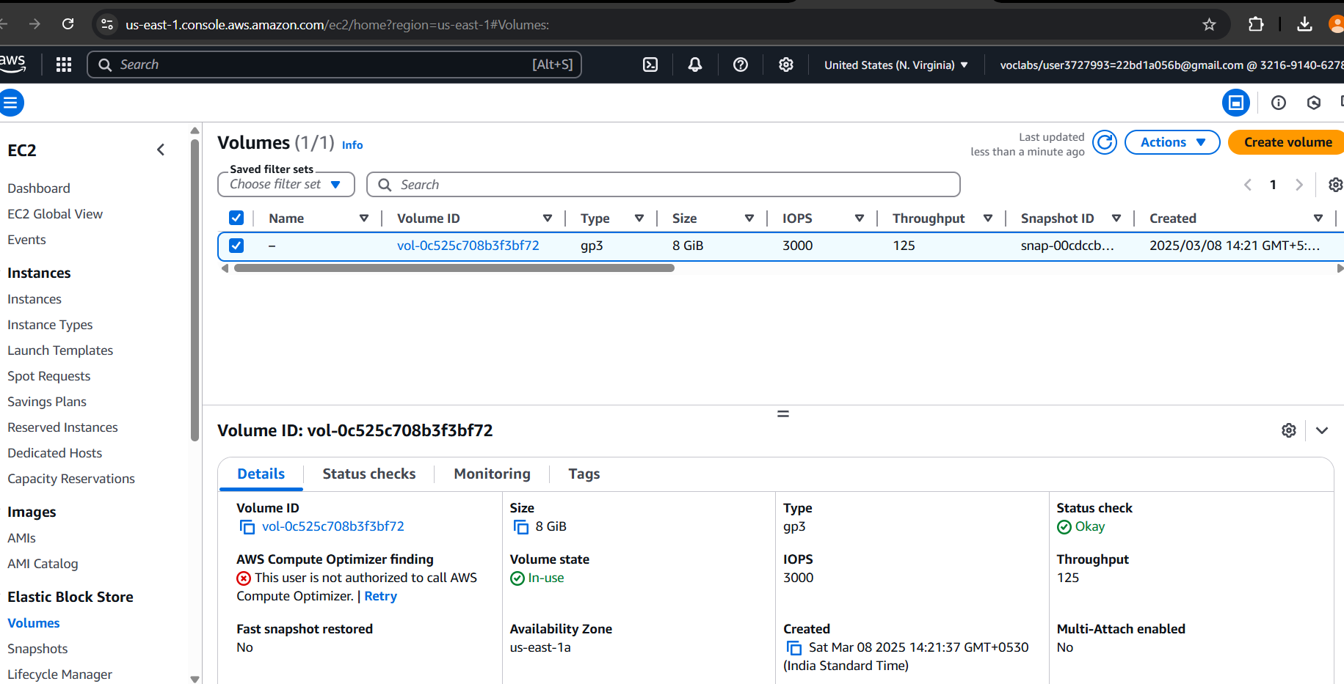
12.Now connect your Instance by clicking connect with EC2 Instance connect
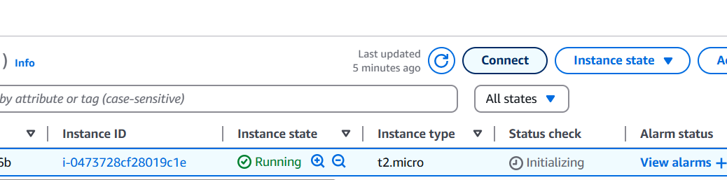
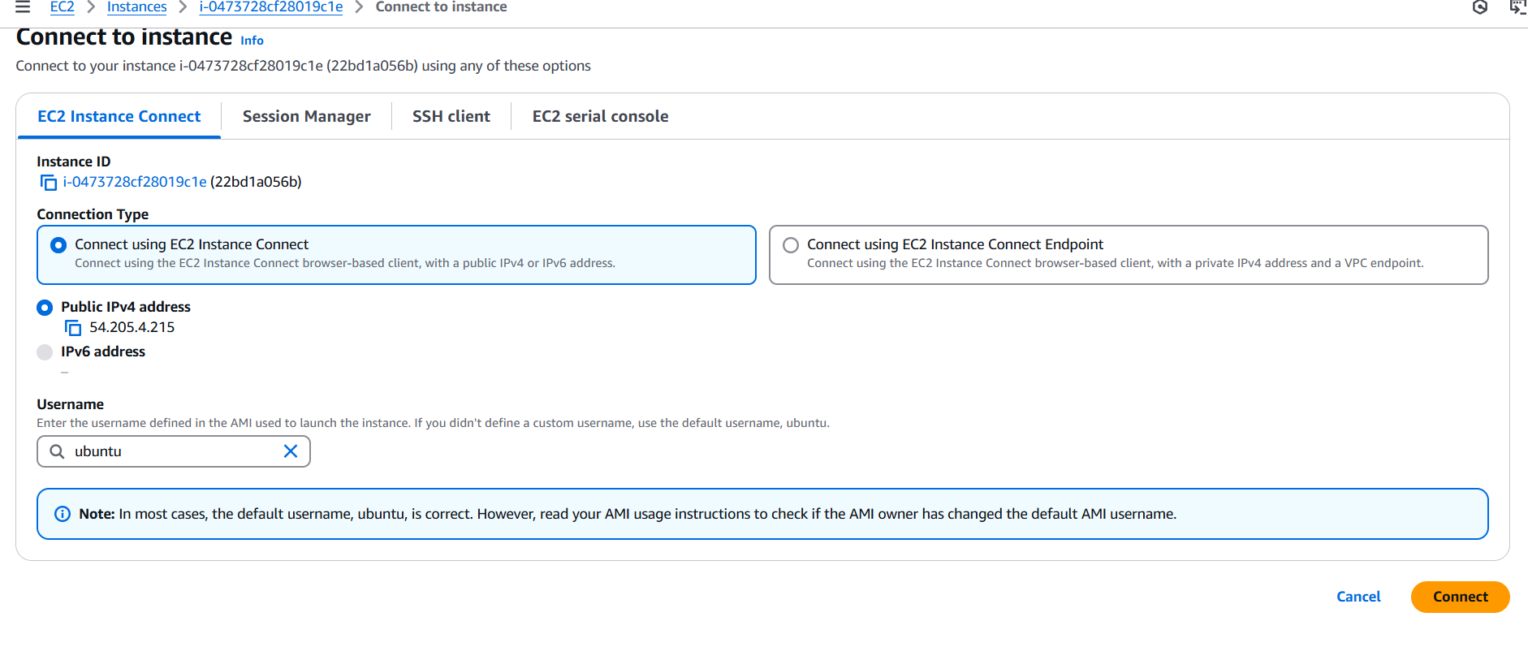
13. Perform commands like root user, disk Info to see volume Size
$ sudo su - //login into root user
$ df -h //shows the volume attached to those devices

14.Click create volume on right most corner of your Page
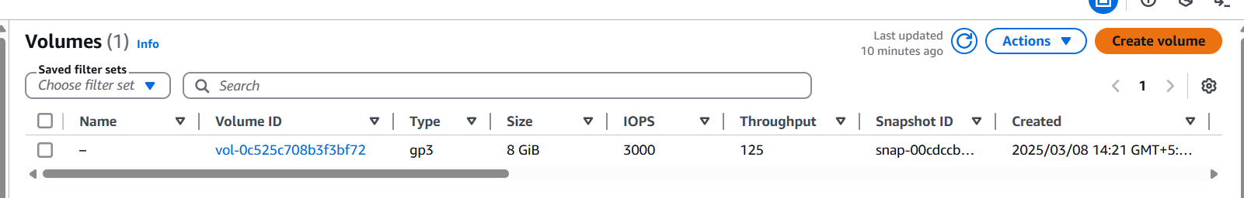
15.Settings:
Volume type: General purpose (gp3) //select based on your requirement
Size (GiB): 10 GiB
Remaining: Default, but Availability Zone should be careful
NOTE: You need to create & attach volume in the same availability Zone & Verify where your instance is exactly located mine is: United States (N. Virginia) us-east-1a

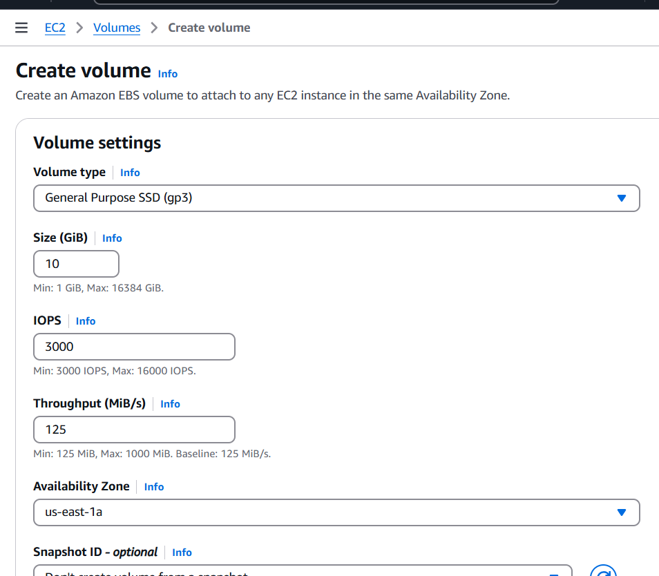
16.Tags: Optional (Add Tag)
Key: 22bd1a057a Value: Extra-Volume-22bd1a057a
Finally Click on Create Volume

17.Volume with 10GiB Created successfully
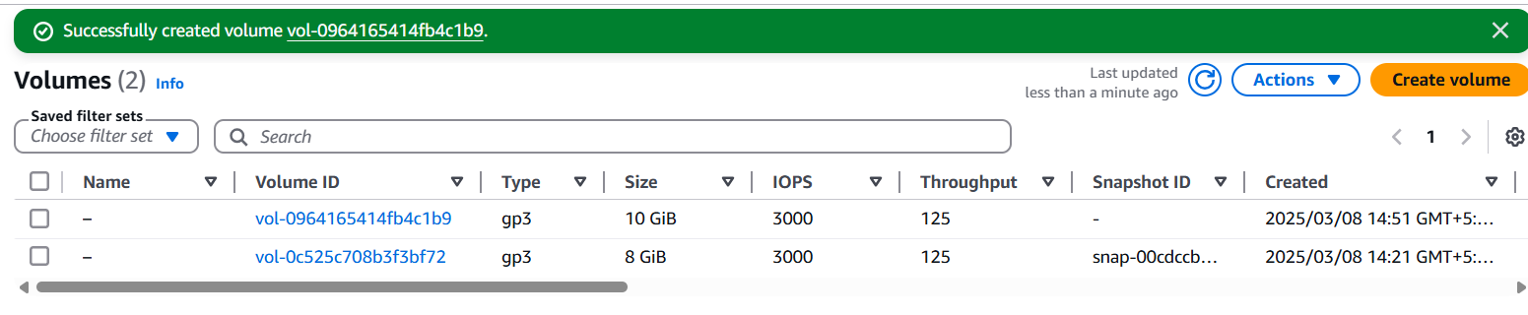
18.Attach Volume:
Now select created Volume and Click on Actions (Besides create volume) and select Attach volume
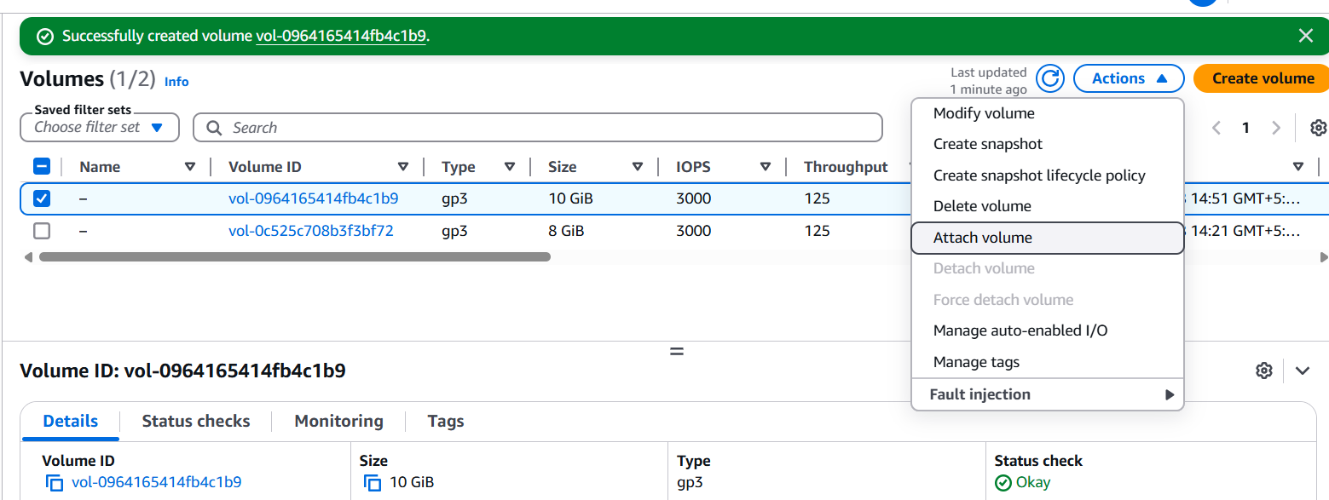
19.Select your Instance you have created – 22bd1a057a
Choose Device name: /dev/sdk (Default)
Click on attach volume
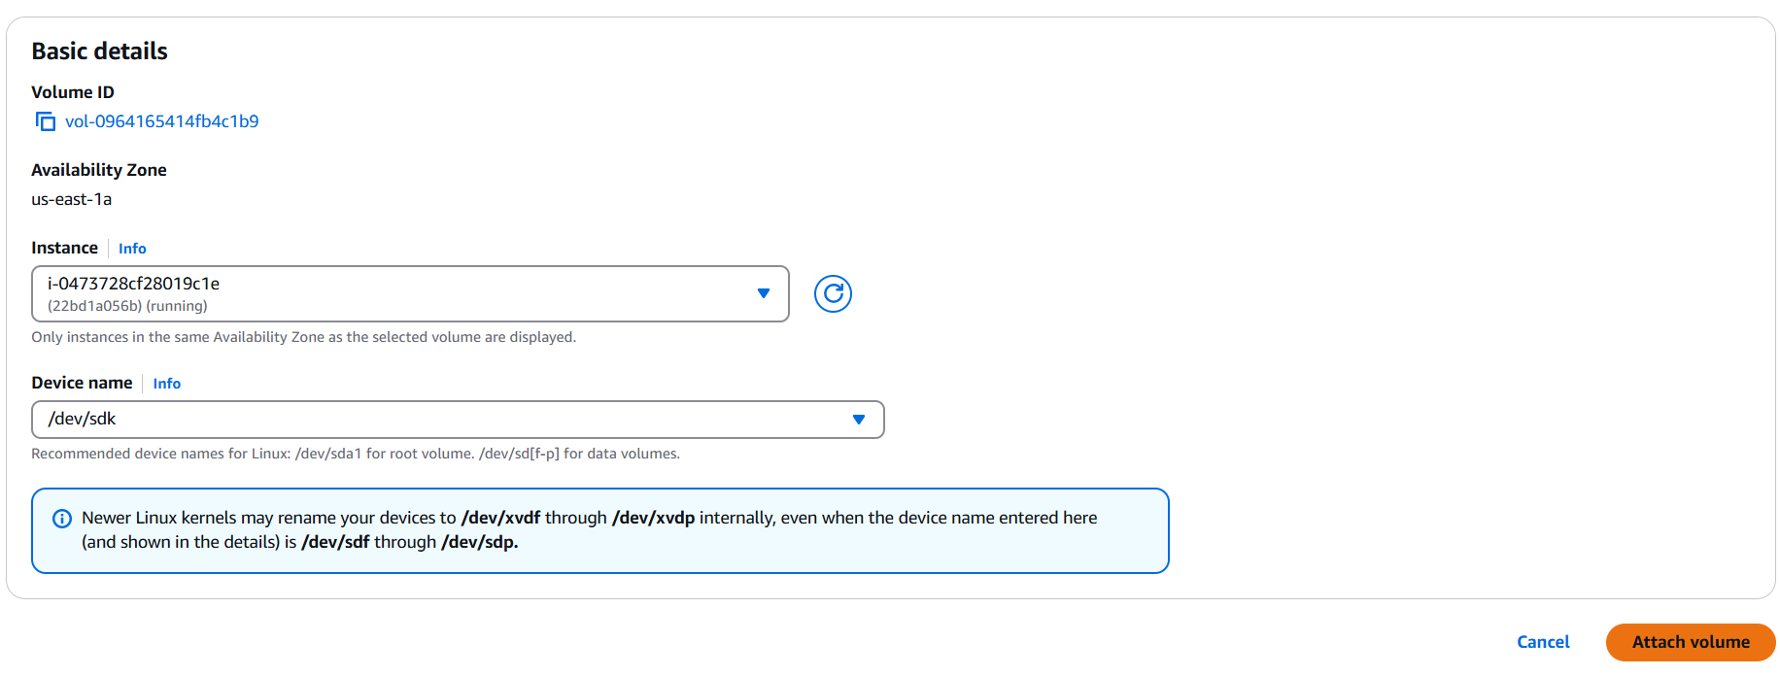
20.It will create volume with 10(GiB) & status is: in-use
Click that volume you can see that Status is insufficient, Wait until Okay (Green)

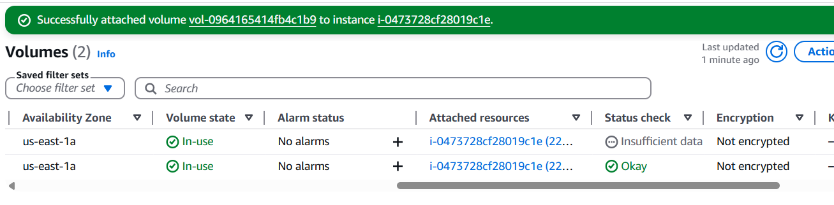
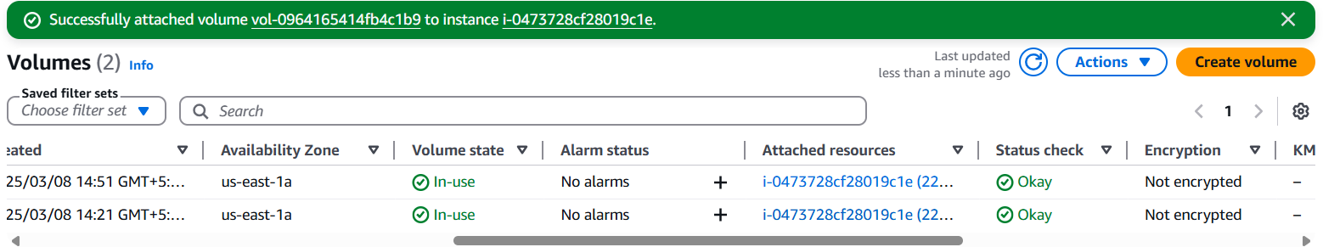
21.Execute following commands:
lsblk
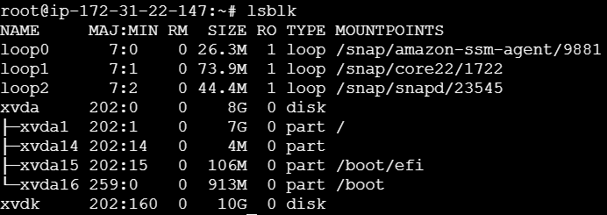
sudo su
lsblk -list
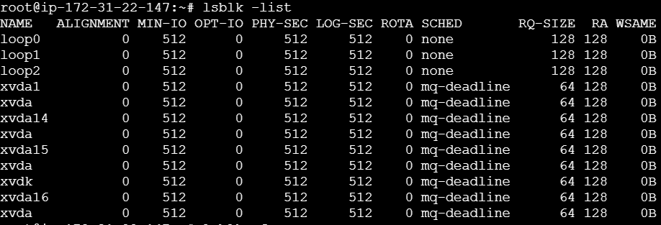
lsblk -fs
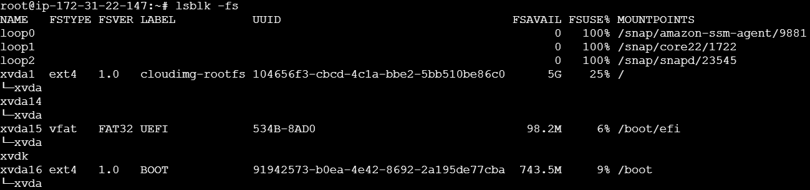
fdisk -l

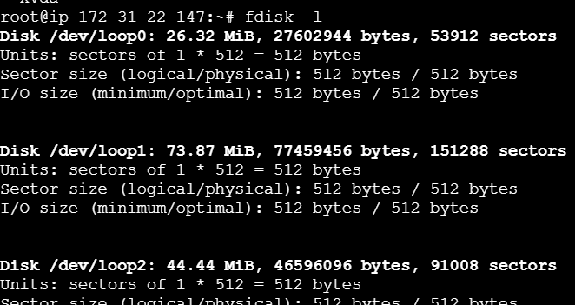
fdisk /dev/xvdk
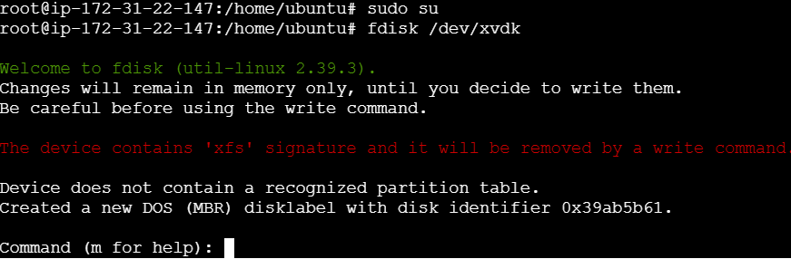
Press: m-help

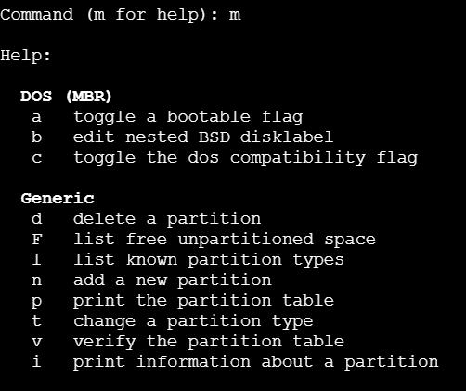
n- add new Partition
p - Primary
Enter (Default Partition)
Enter (First Partition)
Enter (Last Partition)
w - write Changes to disk and exit
partprobe
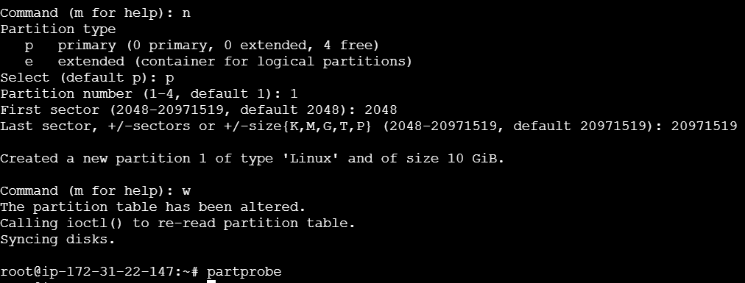
file -s /dev/xvdk
sudo mkfs -t xfs /dev/xvdk
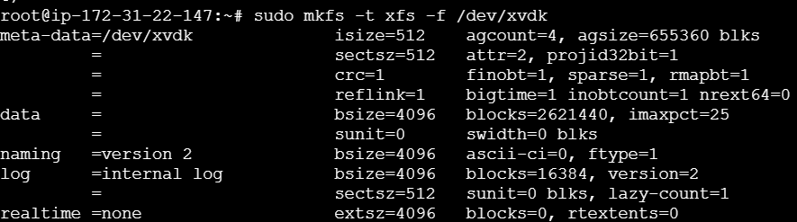
file -s /dev/xvdk
mkdir -p /22bd1a057a
cd /22bd1a057a
touch 1.txt
vi 1.txt
cat 1.txt
22.mount /dev/xvdk /22bd1a057a
23.ls -lart /22bd1a057a/

24.df -h
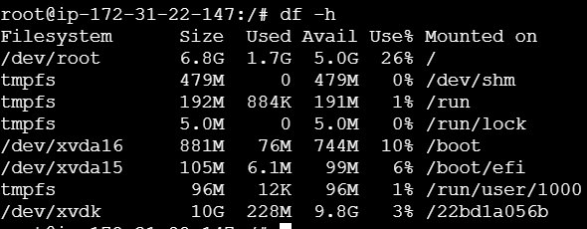
25.fdisk -l
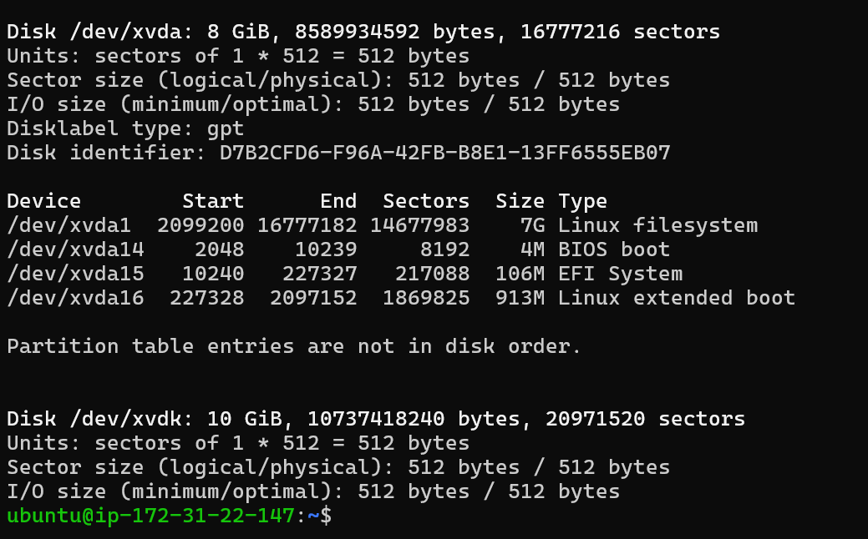
Part-2: Inserting a Files in EBS, Taking a Snapshot & Attaching to another Region EBS
1.Creating files
- pwd
- cd /22bd1a057a
- sudo touch 2.py
- sudo touch 3.java
- ls -lart // To see the File

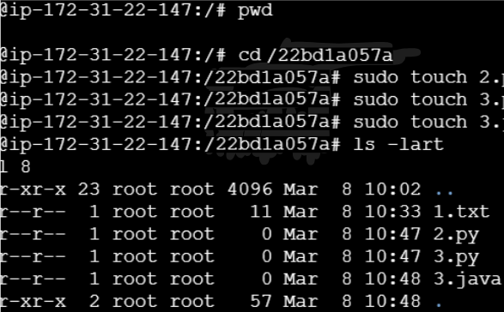
//create a 2.py File & Write add 2 numbers Code
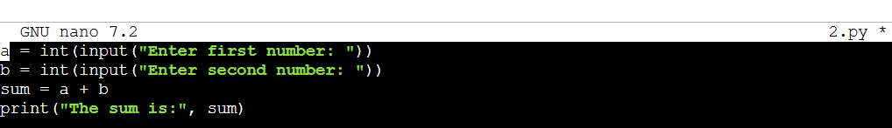
//create a 3.java File & Write Welcome with Roll no Code
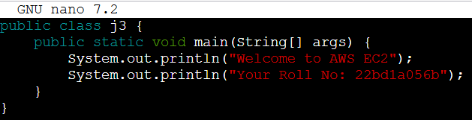

Switch to another region (Oregon)
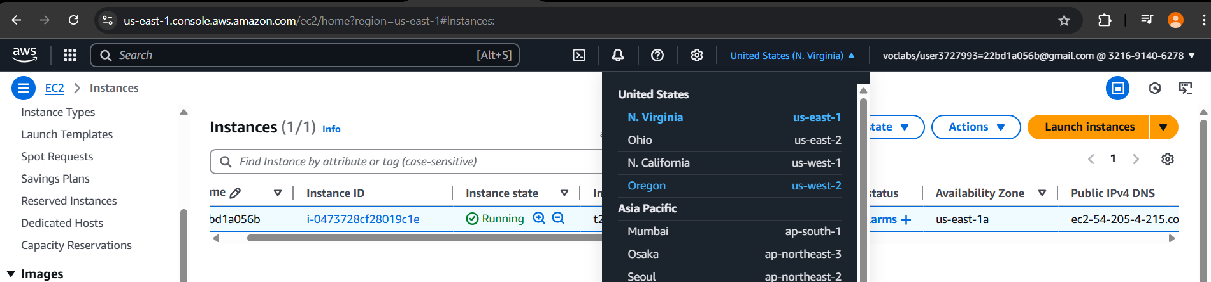
Create Another EC2 instance in this Region
Instance Name: 22bd1a057a_EBS_Oregon

Key Pair: Old One (Existing)
For that we have to import Key Pair of the first instance
Go into Key pairs section
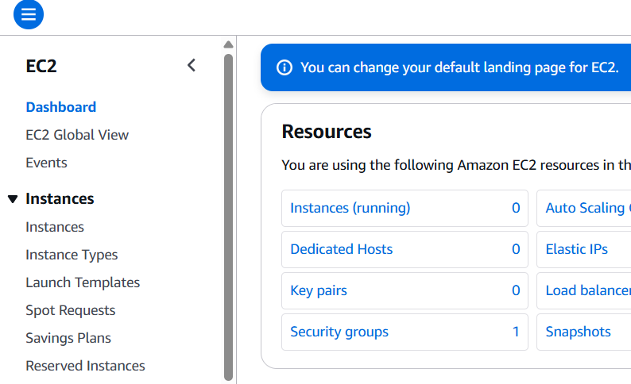
Go to Actions -> Import key pair
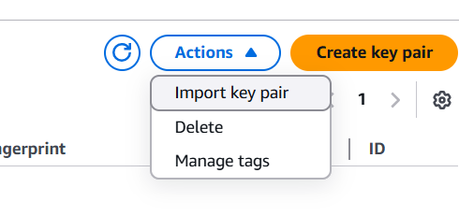
Browse and choose the Key pair of the first instance
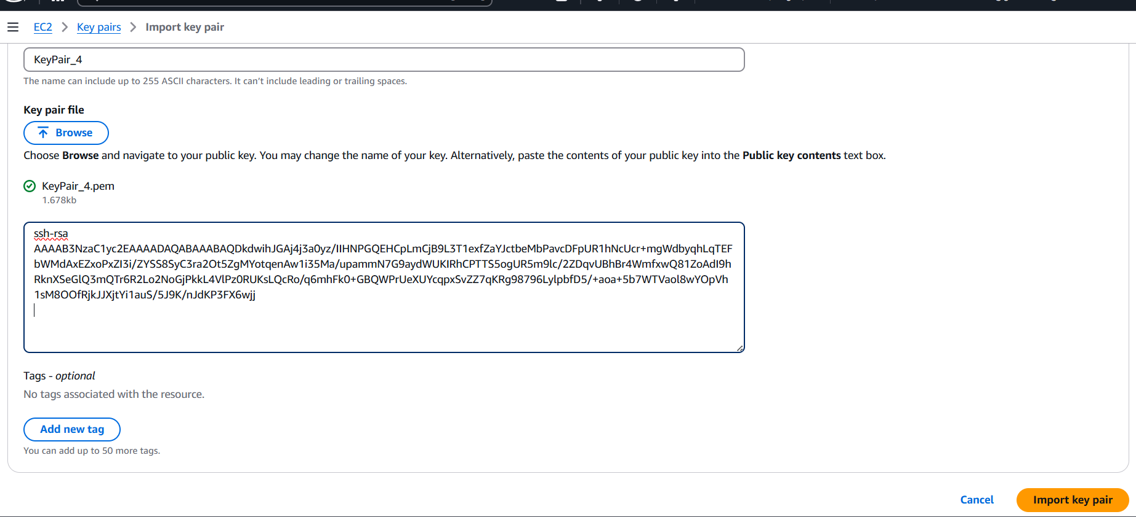
Convert the .pem file to a public key with file name public-key.pub using the command below
Open the public-key.pub file
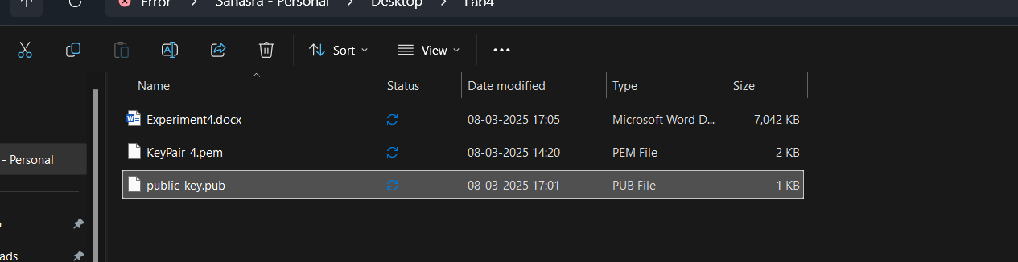
Copy the data present in it

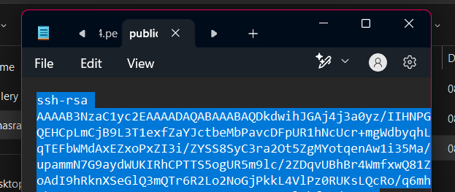
Paste it here and click on “Import key pair”

The key pair is imported
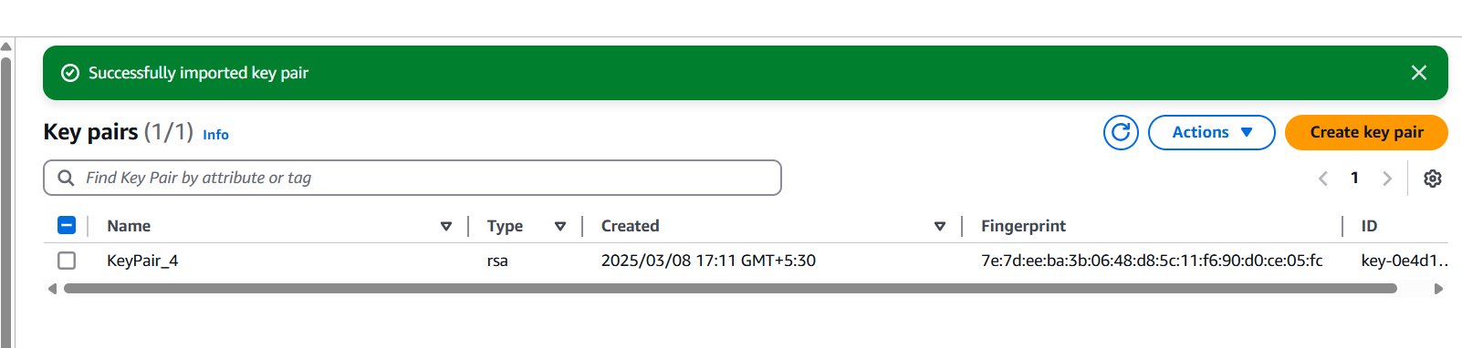
Choose the imported key pair
Default Storage : 8 (GiB)
Launch the instance

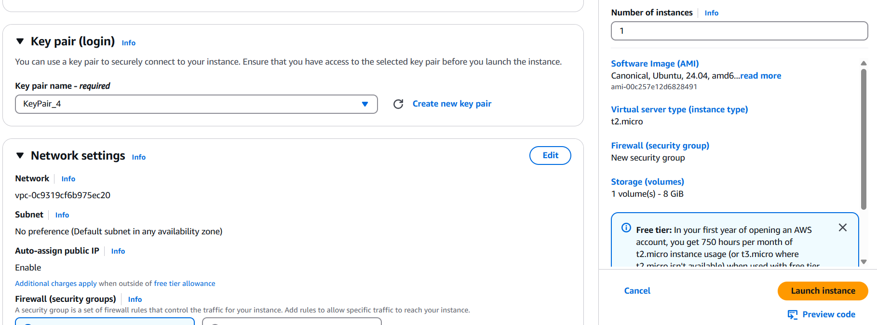
Connect with SSH Client with Command line
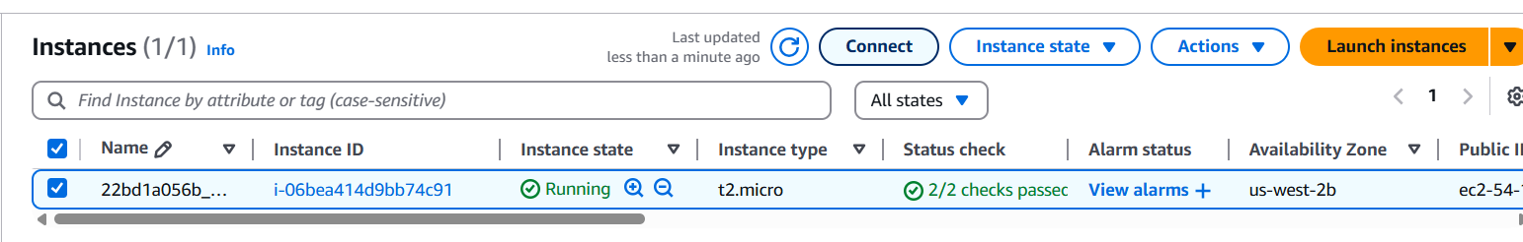
Now Copy the SSH path
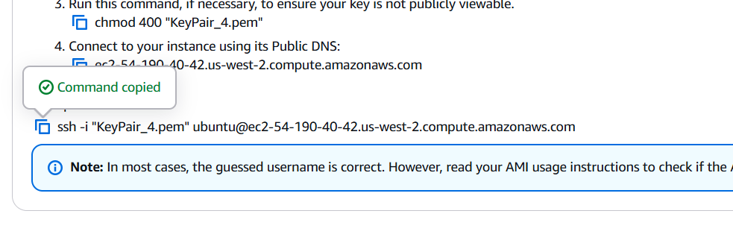
Click Enter & Type Yes
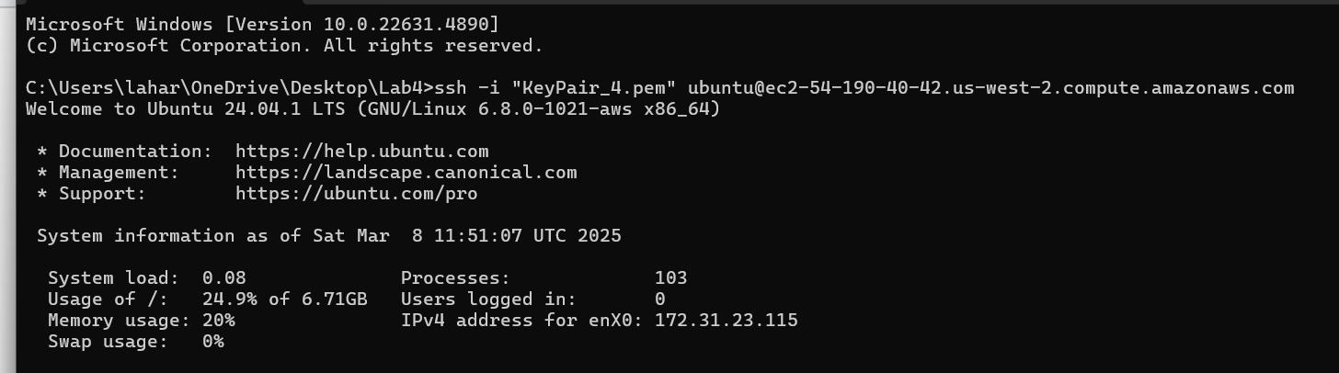
Now type sudo fdisk -l To verify disk size (only 8 GiB will displays)
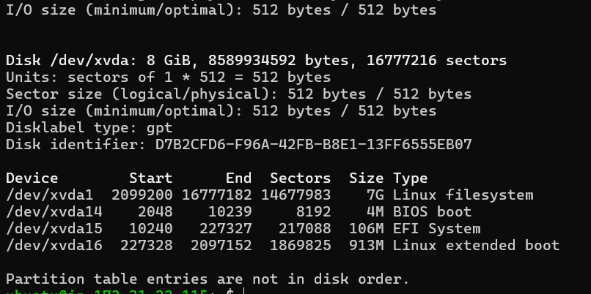
Creating a Snapshot:
Go to old Instance
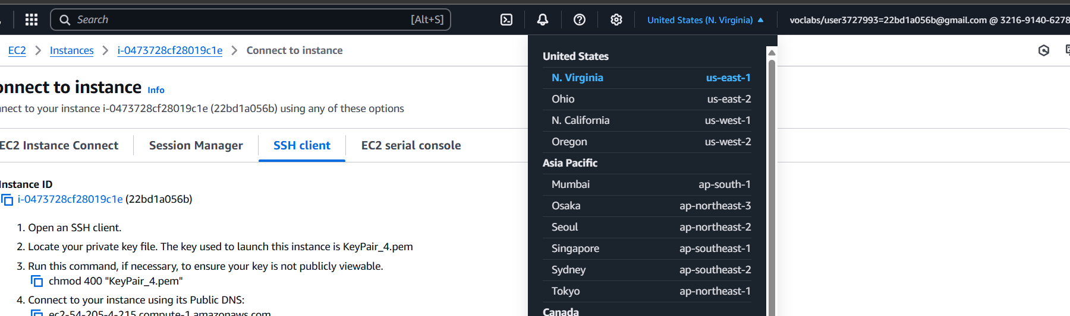
Move to Volumes → Select the Volume 10 GiB
Click on Action → Click on Create SnapShot
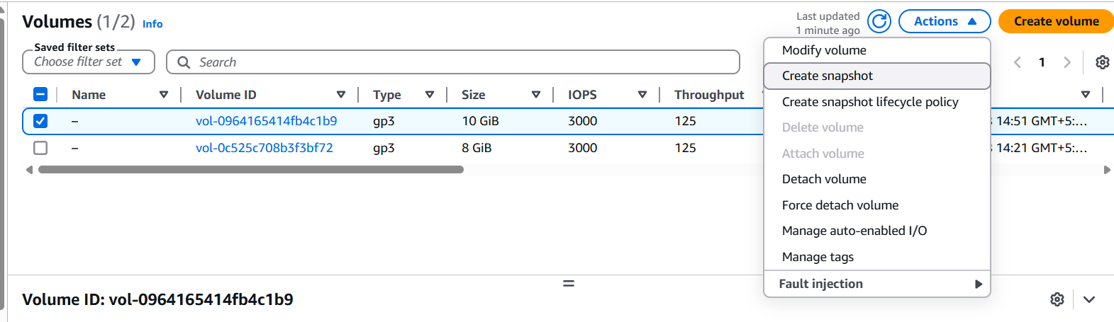
Supply below Snapshot details:
Description: Snapshot_22bd1a057a
Just Click on Create Snapshot

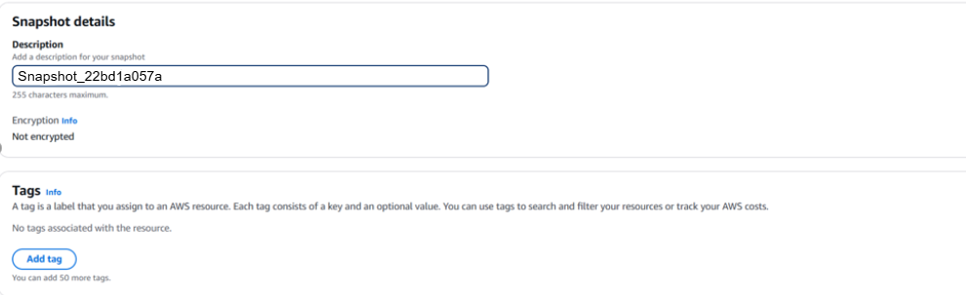
To See Snapshot Go to Left Pallet Elastic Block Store → Snapshot
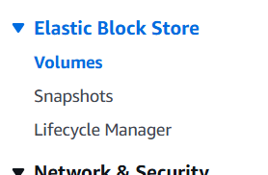
Attach our Snapshot to Second EC2 Instance
Wait Until Snapshot created with Snapshot ID & Status: Okay
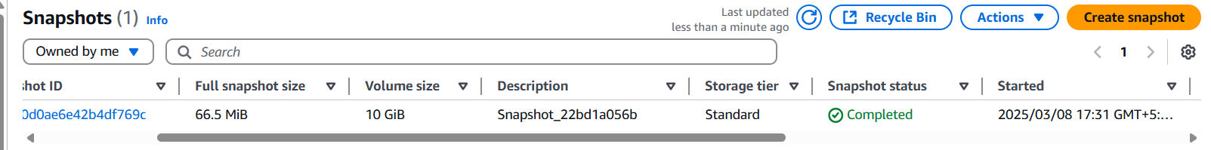
Select the snapshot and go to Actions -> Copy Snapshot
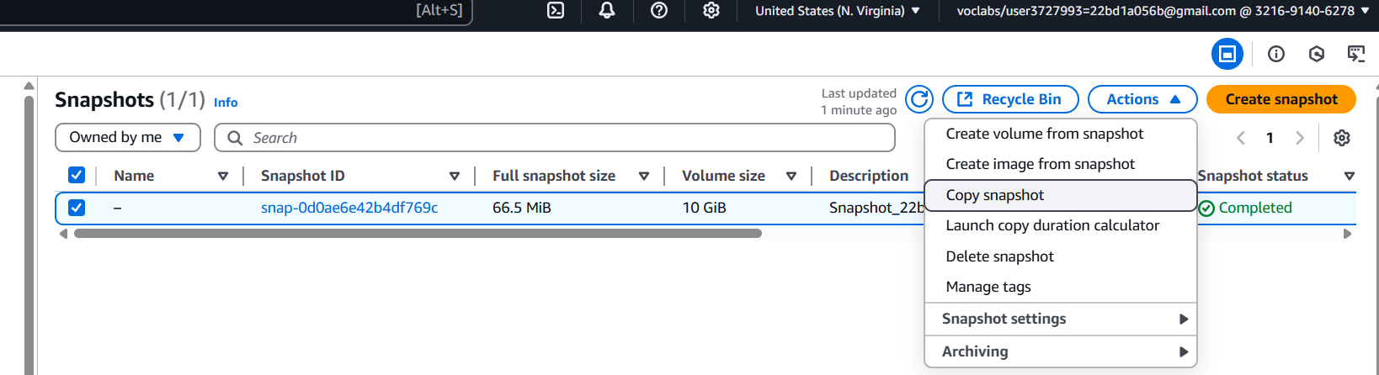
Destination Region: Choose the region where your other region (Oregon) EC2 is present.
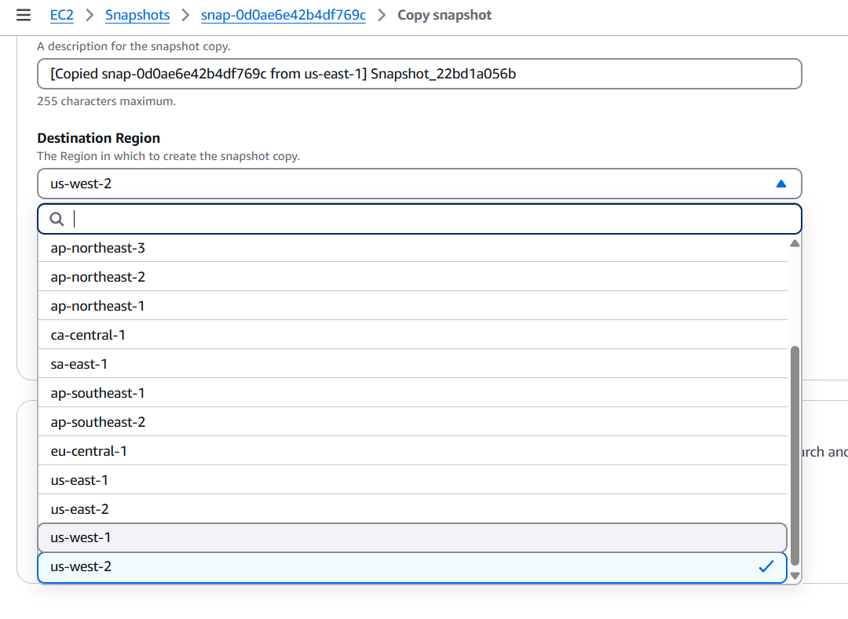
Click on “Copy snapshot”
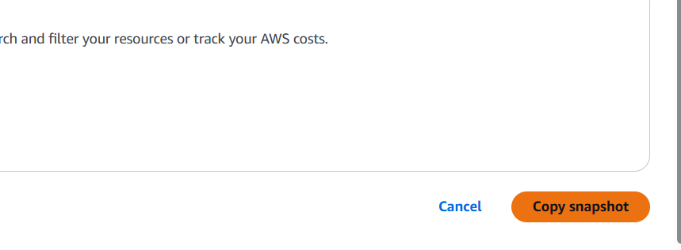
Success

Switch to second region
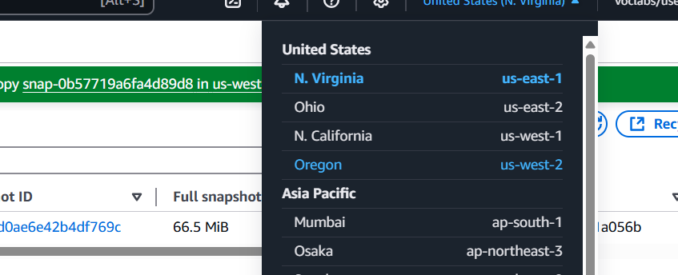
Goto Snapshot → Action → click on Create volume from snapshot
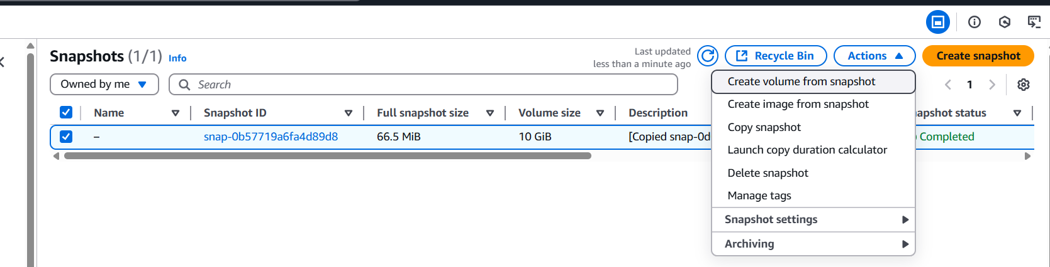
  - You will get Information like
Volume settings, Tags - optional, Snapshot summary
This are default information which are get by Snapshot
Choose “Availability Zone” – Availability zone of your instance in Oregon

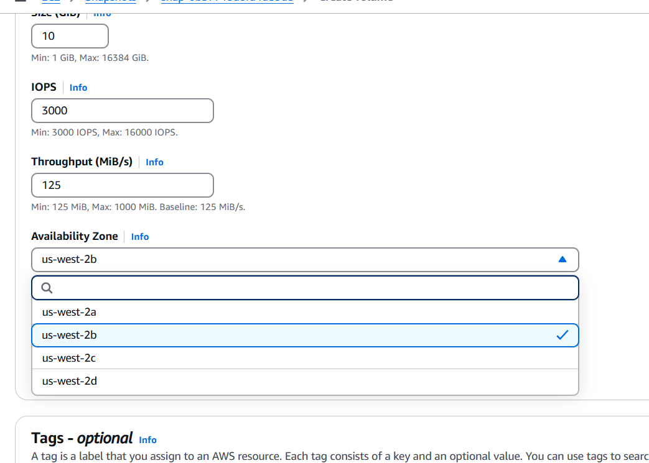
Click on “Create Volume”
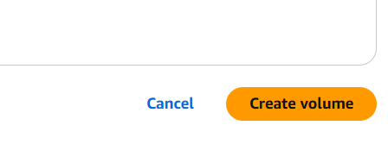
Now it will successfully create volume ID vol-009c1fe312bcc89cd
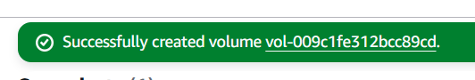
Now Rename the Snap-Volume as Snap-22bd1a056b-Oregon
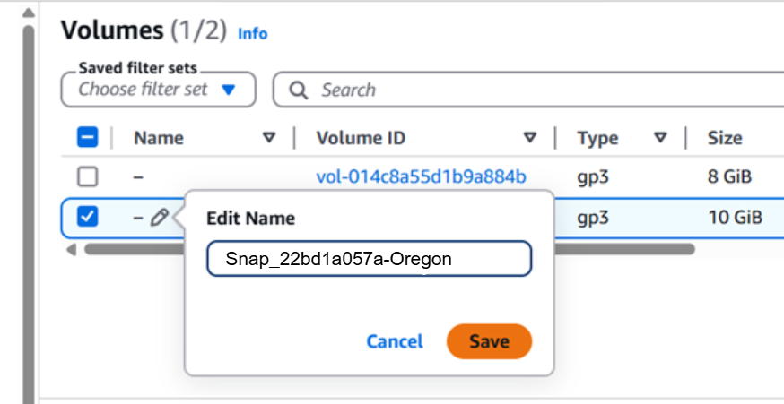
Volume has been renamed
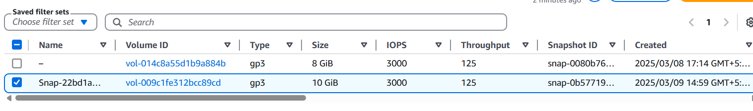
Now Select that volume and Goto → Actions → Attach Volume →
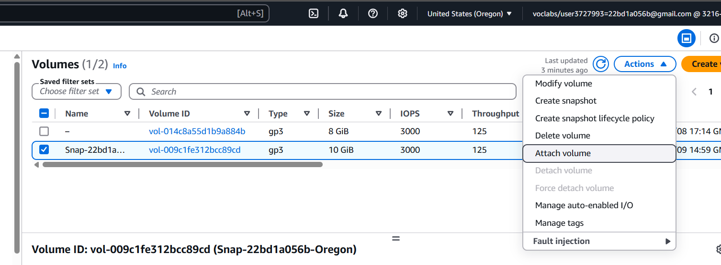
Basic details:
Instance: Select the Instance in Oregon
Device Name: /dev/sdk
Click on attach volume

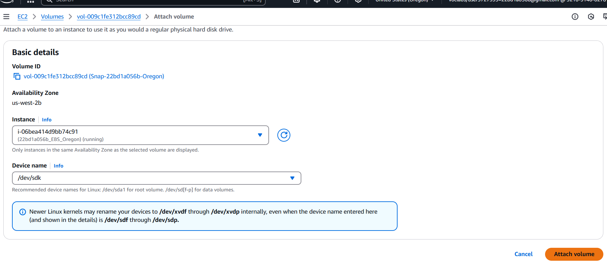
Thats it Volume is attached to other Instance
Connect to Instance using EC2 Instance Connect
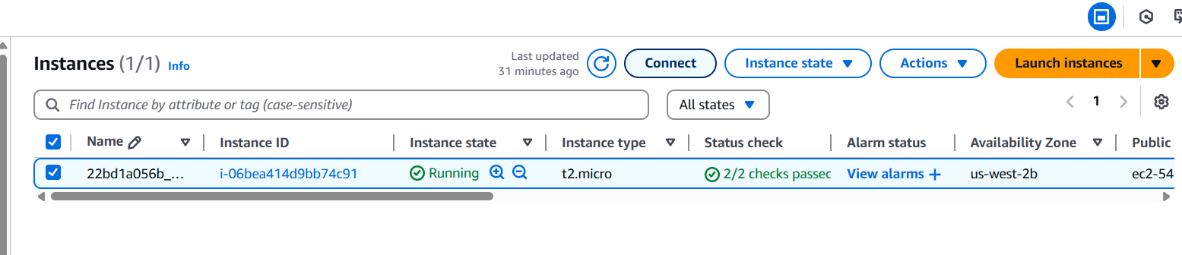
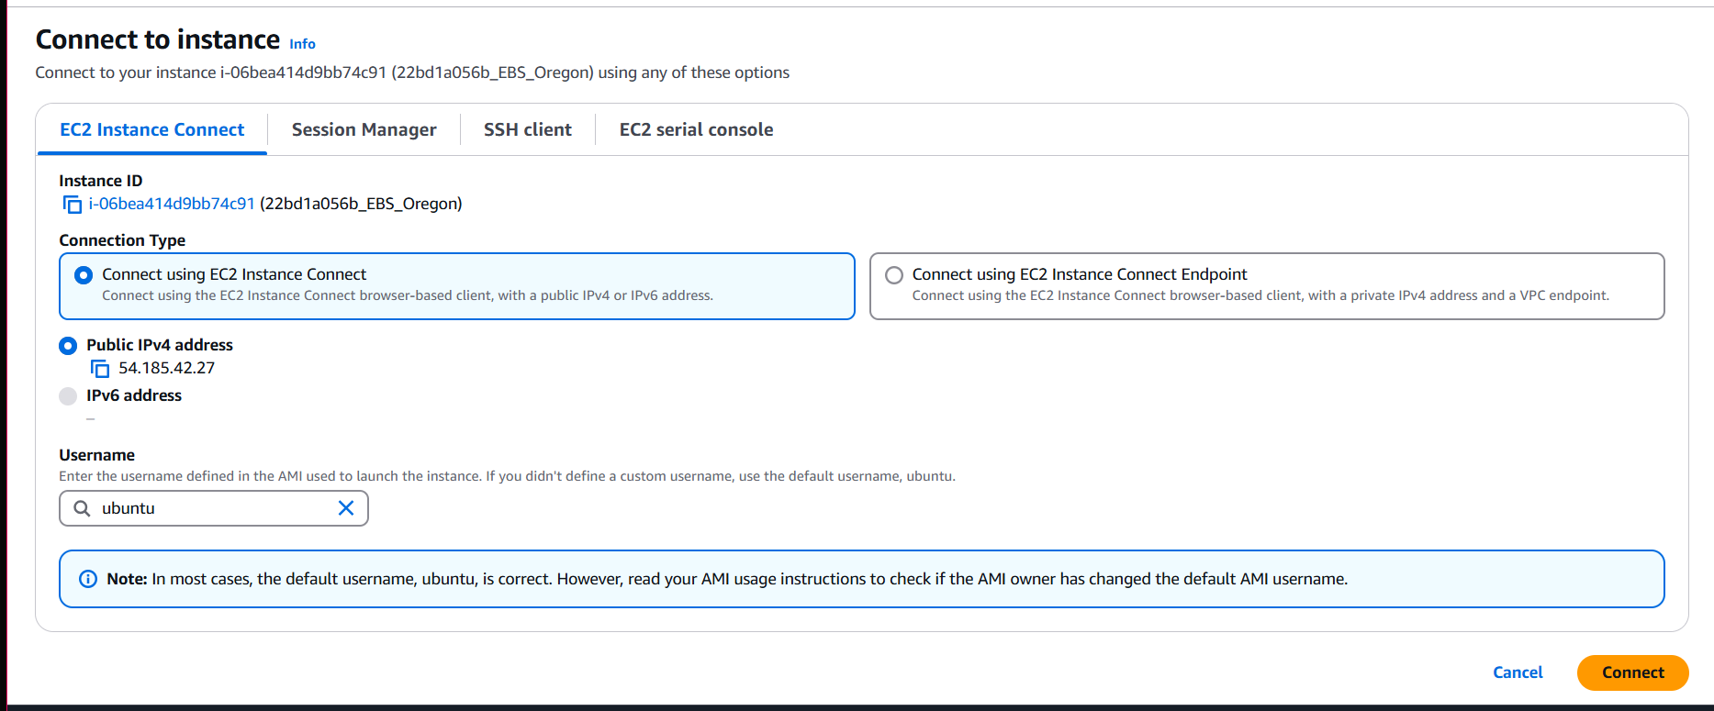

Now run the command as sudo fdisk -l (You will get 10GiB Data Attached)

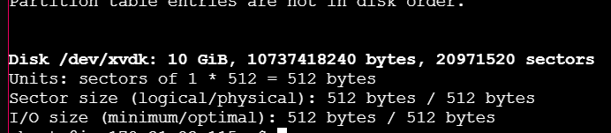
Execute the following commands:
sudo mkdir /22bd1a057a
sudo mount /dev/xvdk /22bd1a057a
ls -lart /22bd1a057a (All Files as to Display 1.txt, 2.py, 3.java in other Region)

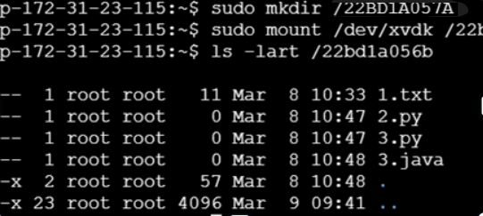
sudo su
file -s /dev/xvdk
ls -lart /22bd1a056b (All Files as to Display 1.txt, 2.py, 3.java in other Region)
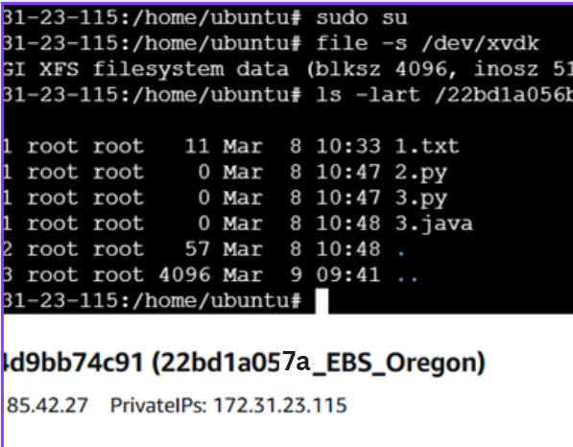

Part-3: ELASTIC FILE SYSTEM (EFS)
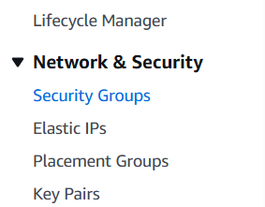
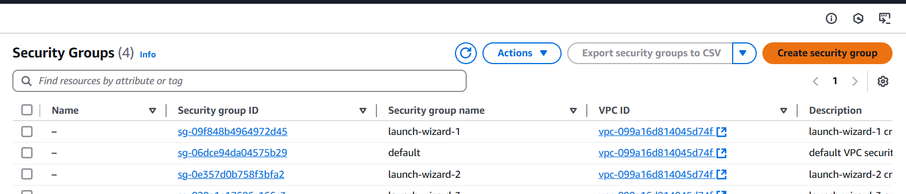

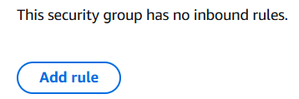
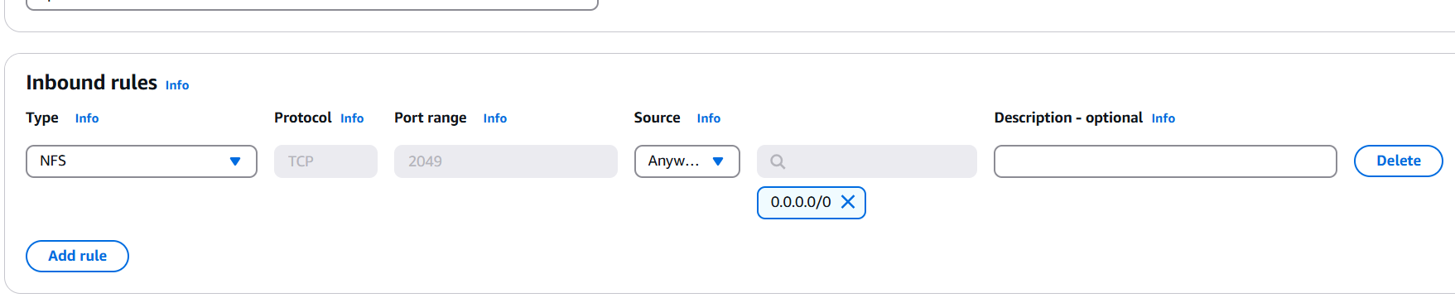
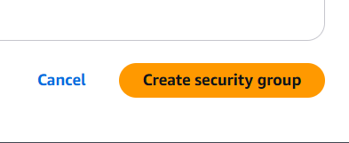
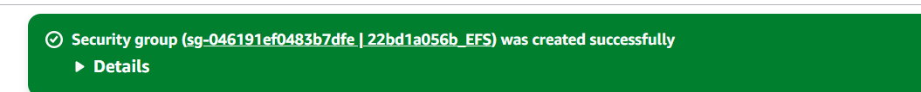

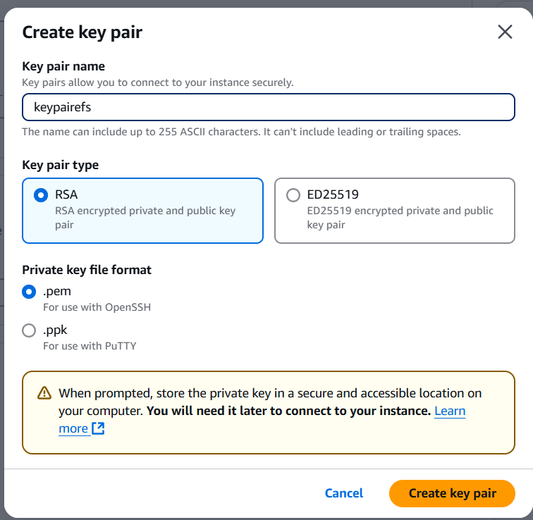
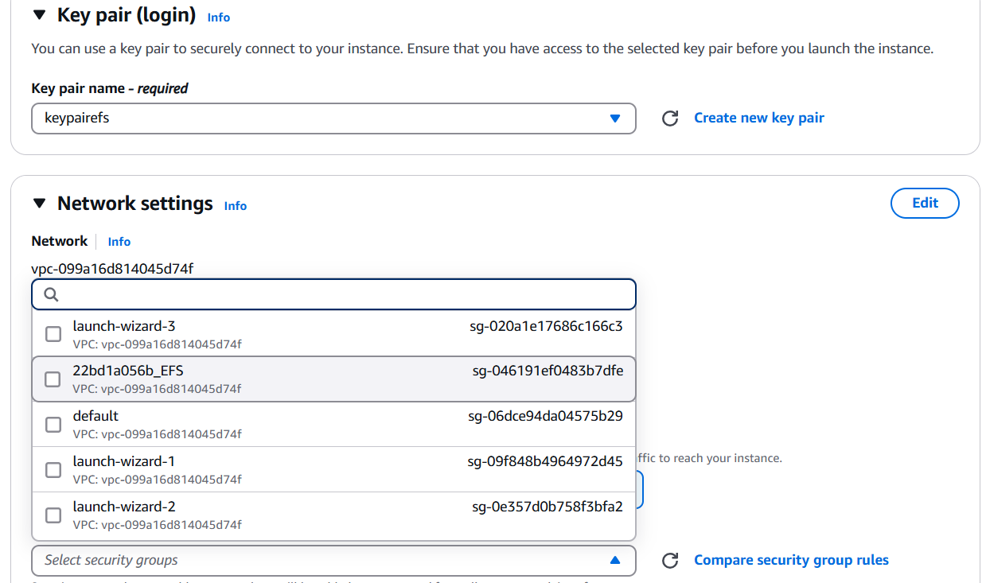
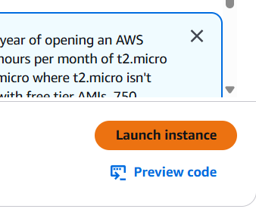

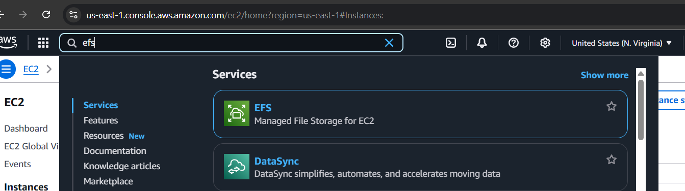
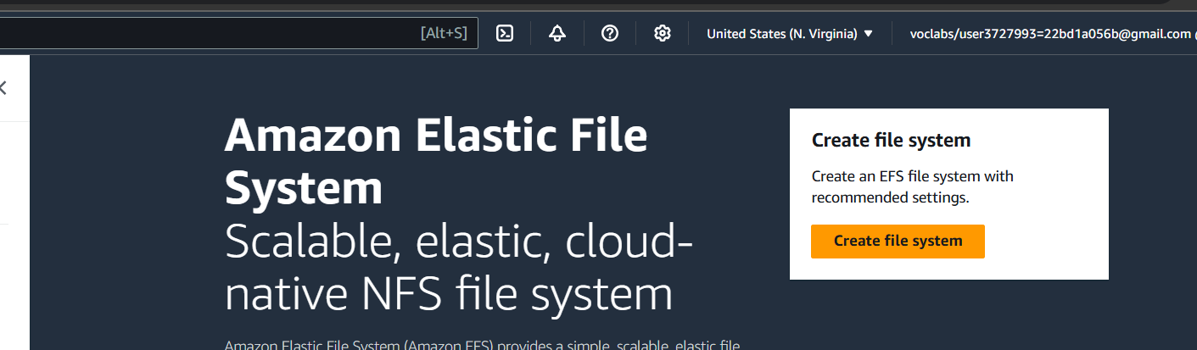
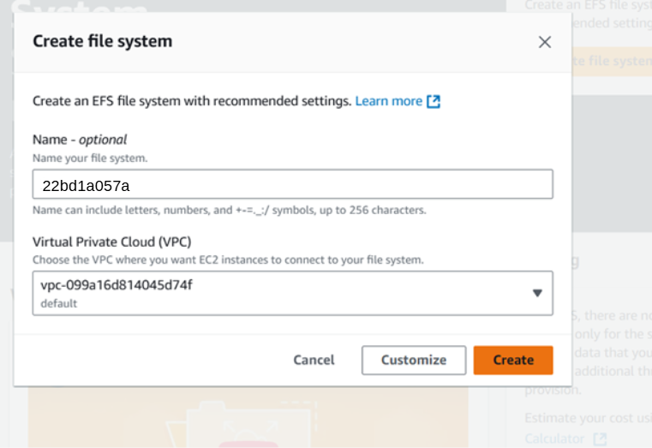
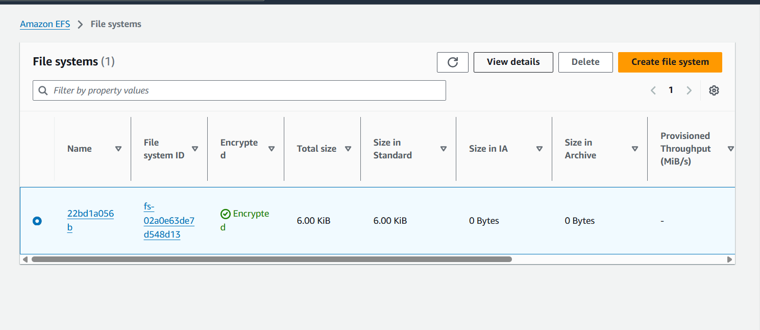

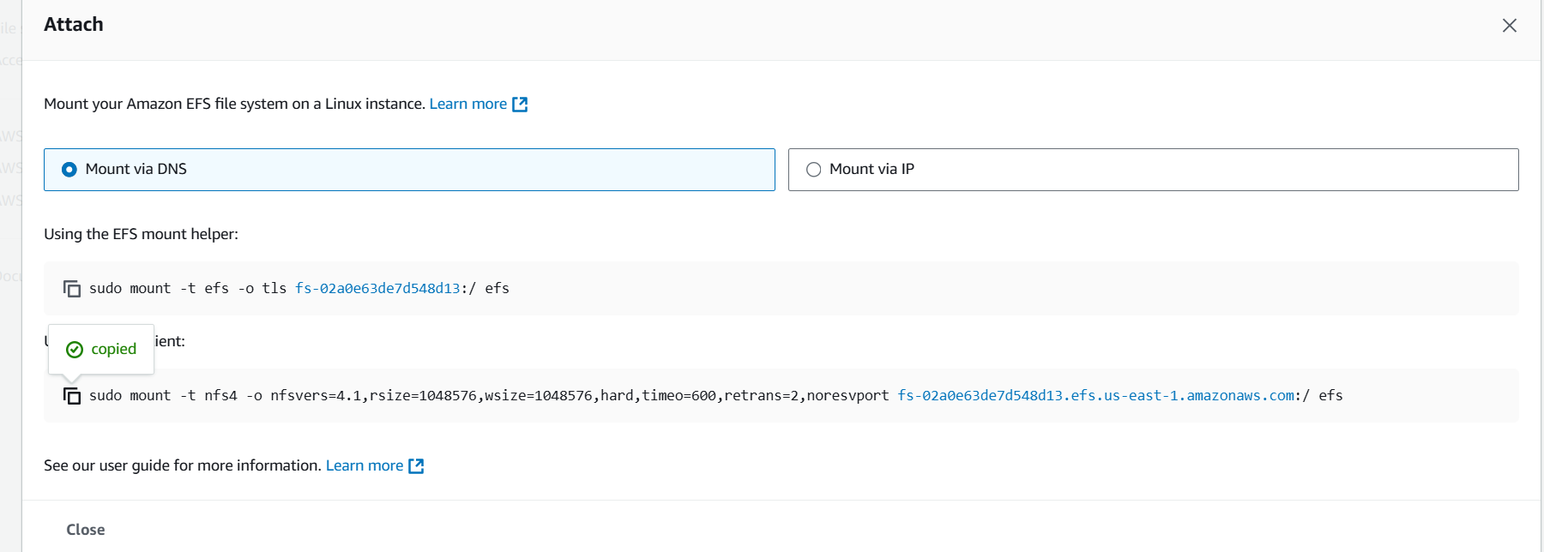
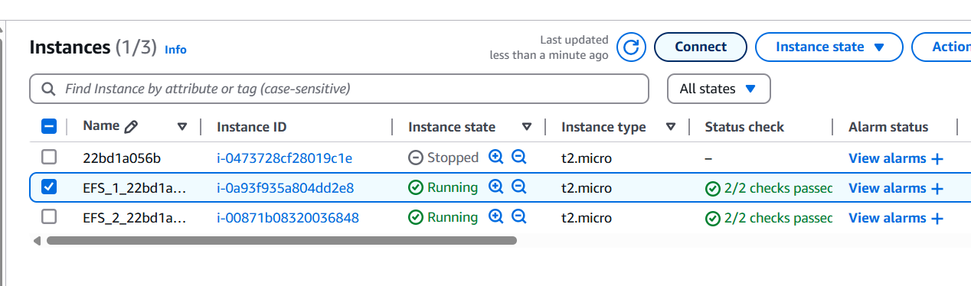
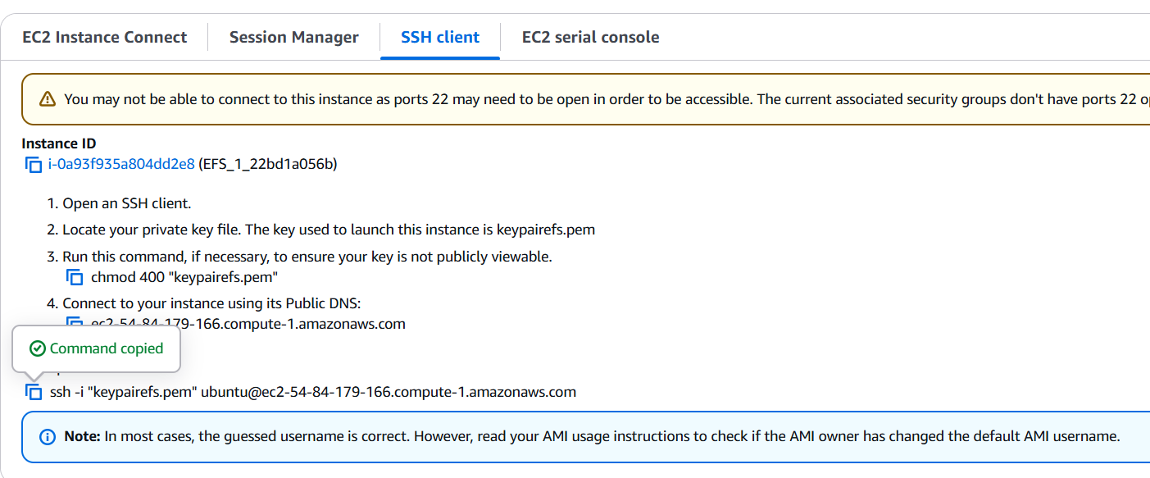
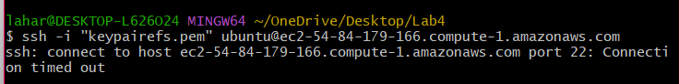
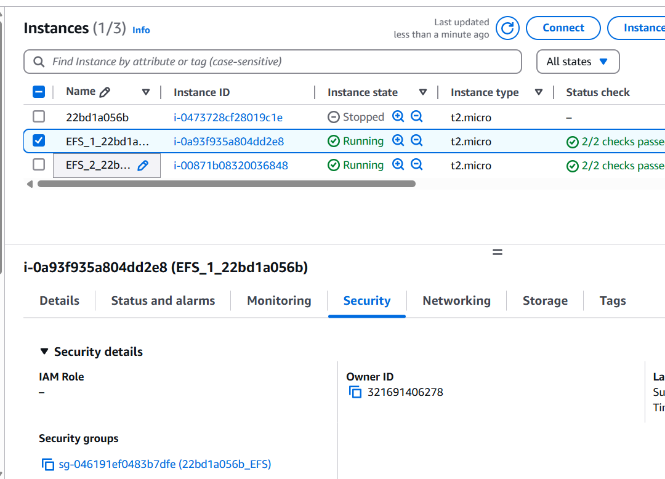
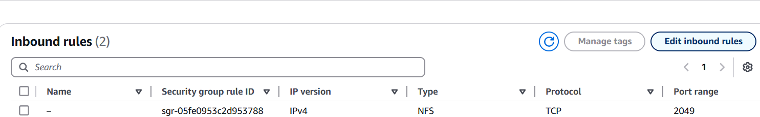
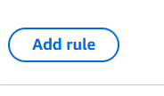
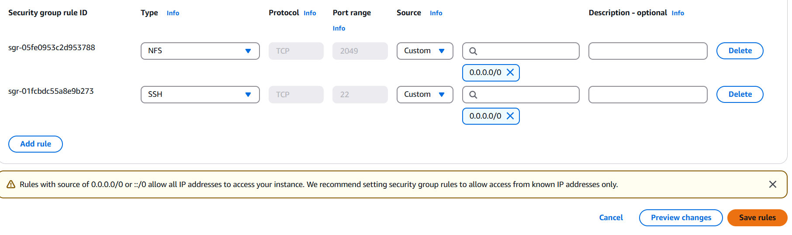
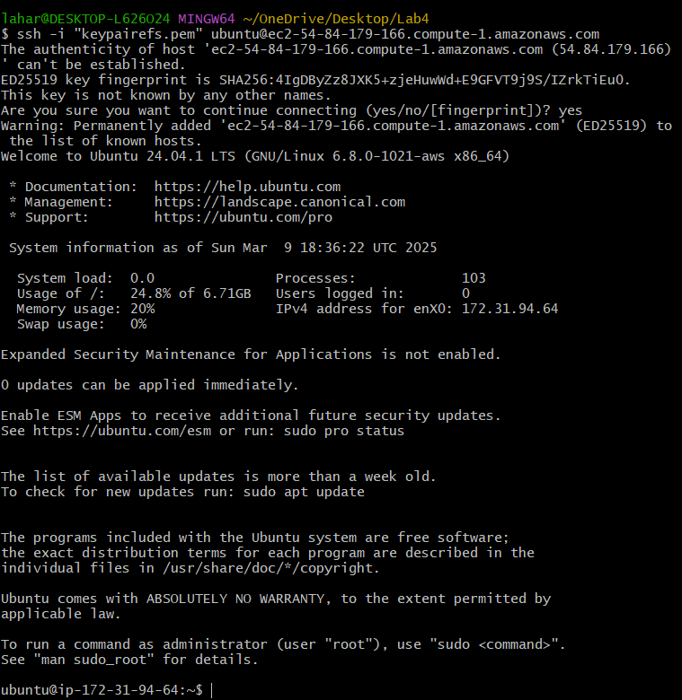

31. End the Lab
